Example of a Neural Network and it’s working- Backpropagation and updation of weights

Suppose, we have the following weights initally initialized:
w1 = 0.15
w2 = 0.20
w3 = 0.25
w4 = 0.30
w5 = 0.40
w6 = 0.45
w7 = 0.50
w8 = 0.55

x1 = 0.05
x2 = 0.10

b1 = 0.35
b2 = 0.60

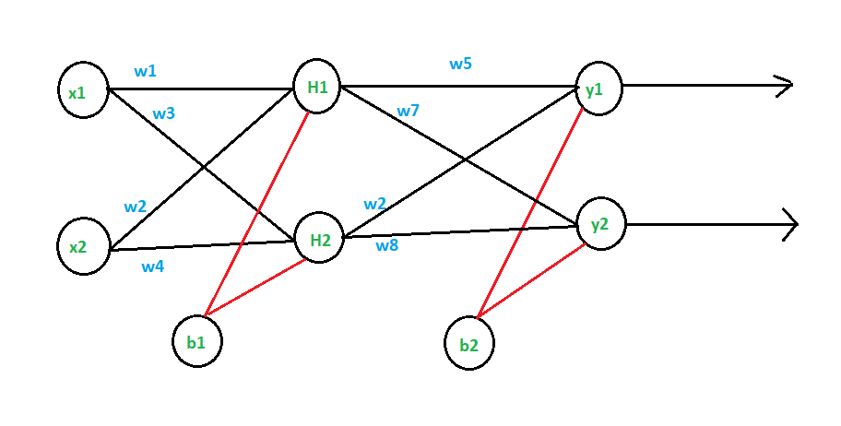

Target values are the following:
T1 = 0.01
T2 = 0.99

Forward Pass
H1 = x1*w1 + x2*w2 + b1
= 0.05*0.15 + 0.10*0.20 + 0.35 = 0.3775

out_H1 = (1/(1 + e^(-H1))) = (1/(1 + e^(-0.3775))) = 0.59326

Similarily for H2,
H2 = x1*w3 + x2*w4 + b1
= 0.05*0.25 + 0.10*0.30 + 0.35 = 0.3925

out_H2 = (1/(1 + e^(-H2))) = 0.596884

Now, Calculating y1,

y1 = out_H1*w5 + out_H2*w6 + b2
= 0.40*0.59326 + 0.596884*0.45 + 0.60
= 1.10590

out_y1 = (1/(1 + e^(-y1))) = (1/(1 + e^(-1.10590))) = 0.75136

Similarily for y2,
y2 = out_H1*w7 + out_H2*w8 + b2
= 0.50*0.59326 + 0.596884*0.55 + 0.60
= 1.22491

out_y2 = (1/(1 + e^(-y2))) = (1/(1 + e^(-1.22491))) = 0.772928

Calculating total loss, we get

E_total = Summation over all (1/2)*(target – output)
= (1/2)*(T1 – out_y1)^2 + (1/2)*(T2 – out_y2)^2

E1 E2

= (1/2)*(0.01 – 0.751)^2 + (1/2)*(0.99 – 0.772)^2
= 0.29837

Backward Pass to update the weights,
Consider the weight w5,

Error at w5 = d(E_total)/d (w5)

d(E_total)/d (w5) = d(E_total)/d (out_y1) * d(out_y1)/d (y1) * d(y1)/d (w5)

d(E_total)/d (out_y1) = -(T1 – out_y1) = -(0.01 – 0.75136) = 0.74136

d(out_y1)/d (y1) = out_y1 * (1 – out_y1) = 0.186815

d(y1)/d (w5) = out_H1 = 0.5932

d(E_total)/d (w5) = 0.74136 * 0.186815 * 0.5932
= 0.0821 <-----Change in w5

w5 = w5 – learning_rate * d(E_total)/d (w5)
= 0.40 – 0.0821

= 0.3179

Other can be calculated similarily.

Now, looking at the hidden layer and updating it’s weights,
Consider, updating w1

d(E_total)/d (w1) = d(E_total)/d (out_H1) * d(out_H1)/d (H1) * d(H1)/d (w1)
d(E_total)/d (out_H1) = d(E1)/d (out_H1) + d(E2)/d (out_H1)

= 0.055399 * 0.019049 = 0.0105529

d(E1)/d (out_H1) = d(E1)/d (y1) * d(y1)/d (out_H1)

= 0.138498 * w5 = 0.138498 * 0.40
= 0.055399

d(E1)/d (y1) = d(E1)/d (out_y1) * d(out_y1)/d (y1)
= 0.138498

d(out_H1)/d (H1) = out_H1 * ( 1 – out_H1 )
= 0.59326 * ( 1 - 0.59326 )
= 0.2413025

d(H1)/d (w1) = x1 = 0.05

Hence, the total error with respect to w1 is following:

d(E_total)/d (w1) = 0.0105529 * 0.2413025 * 0.05
= 0.00012732

Finally, updating w1

w1 = w1 - learning_rate * d(E_total)/d (w1)

= 0.15 - 0.5 * 0.00012732

= 0.1499

Similarily, other weights can be updated.

